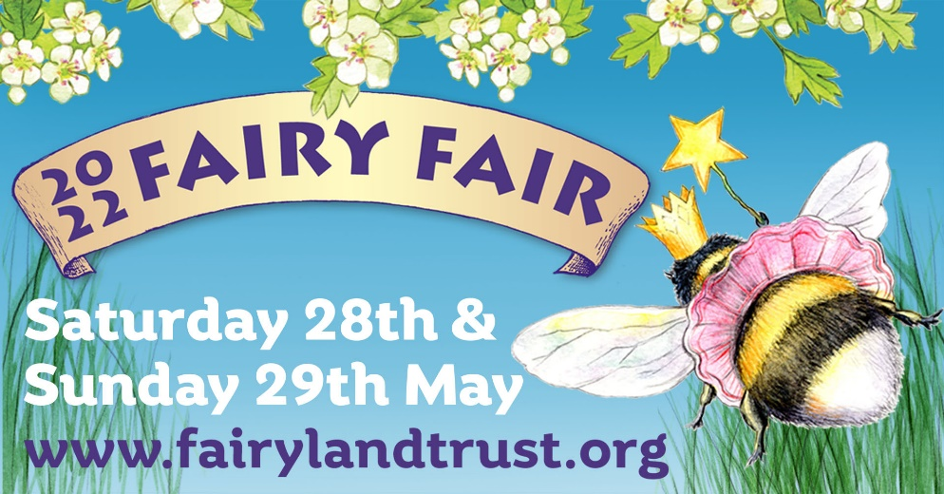
Fairy Fair Trader Enquiry

Name

Trading Name

Address

Contact Number

Email Address

Website Address

Your goods and the description of your goods (Remember to include photographs)

If you are a caterer, please note all food should be vegetarian or vegan. Please include a menu where possible, or detail items sold.

Stall / Pitch Size of stall – width then depth

Description of stall and décor

Public Liability Insurance Certificate enclosed

Risk Assessment / I have enclosed my risk assessment documentation.

Please confirm you have read the merchandise policy

Setting Up
You must be set up and ready to trade by 10am each day. No vehicles will be allowed on site following 9.30am

Arrival I plan to arrive on Friday Saturday Sunday (circle/mark relevant day)

Please detail the name/s of those helping you during the event

Will you have any children attending?

Camping – Please delete as necessary

I do not wish to camp at The Fairy Fair
I plan to camp at The Fairy Fair
The nights I will camp Friday night Saturday night Sunday night (circle/ mark relevant days)
I will be camping in the following (e.g. Campervan / tent)

Crew Catering
I can stay open 60 minutes after event closes to allow crew and traders to purchase food
I can offer a crew discount (catering traders only)
Detail discount to be offered

Power / Electric - CATERING TRADERS ONLY
I do not need power
I need power and have enclosed a fee of £20.00
please detail your power requirements below and anticipated KVA

Agreement
- I confirm the details I have provided on this form are correct and my goods adhere to The Merchandise Policy. No plastic
- I agree to make a payment of 15% of my total takings from Saturday and Sunday, net of the pitch booking fee deposit paid in advance. This must be paid when the event closes on Sunday evening.
- I understand the guidelines regarding no vehicles on Fairy Fair site or movement during Fairy Fair opening times.
- I agree to leave the site clean for both my pitch and camping area and take away any landfill rubbish/ or packaging.
- I understand it is necessary to have public liability insurance and complete a risk assessment to allow me to trade at The Fairy Fair.

Signed ......................................................................................................................................
Date

